System requirements

Client installation
Hardware, minimum requirements
Minimum of 4 Mb RAM
Hard disk with minimum 200 Mb free space

Operating system
Windows XP/NT 4.0(SP 6)/windows 7, Windows 8

Installed software
- .net framework 3.5 or later
- Microsoft Mobile Center (For export/import with mobile units)

Application Server
Hardware, minimum requirements
4 Gb RAM
Hard disk with minimum 500 Mb free space
Windows Server 2008 or later

Database Server (Can be same as Application server)
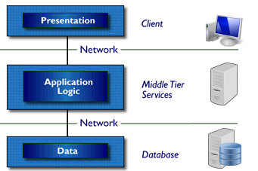
Hardware, minimum requirements
SQL Express 2005 or later
SQL 2005 or later
4 Gb RAM
Hard disk with minimum 2 Gb free space
Windows Server 2003 or later

