- Step 1
  - Click Next to Continue Setup

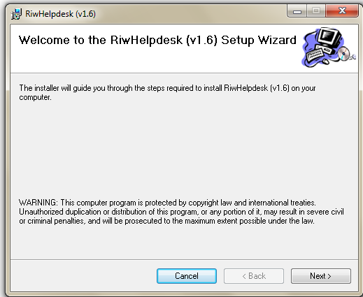

- Step 3

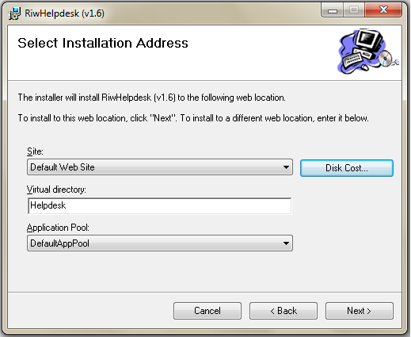

  - Click Next to continue Setup.

- Step 4

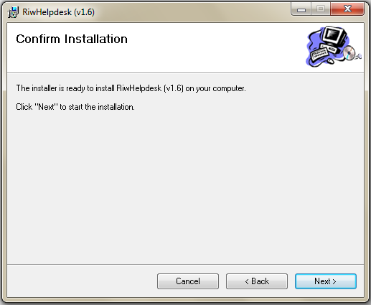

- Step 6

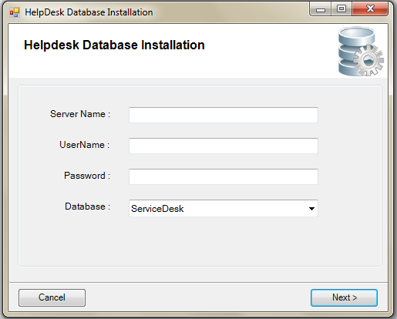

  - Enter SQL Server Name in Server Name Text Box.

  - Enter SQL Server User Name in Username Text Box.

  - Enter SQL Server Password in Password Text Box.

  - Enter Database Name In Database Combo Box.

  - Click Next to complete DB Setup.

- Step 7
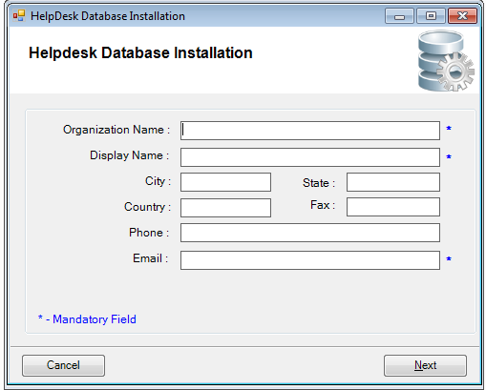

  - Enter Organization Name in Organization Name Text Box.

  - Enter Display Name in Display Name Text Box.

  - Enter Email in Email Text Box.

  - Click Next to Complete Organization Detail.

- Step 8
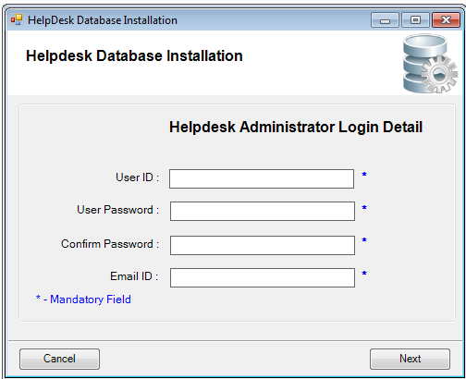
  - Enter User Name In UserId Text Box.

  - Enter Password In User Password Text Box.

  - Enter Confirm Password In Confirm Password Text Box.

  - Enter Email In Email Text Box.

  - Click Next to Complete Login Detail.

- Step 9

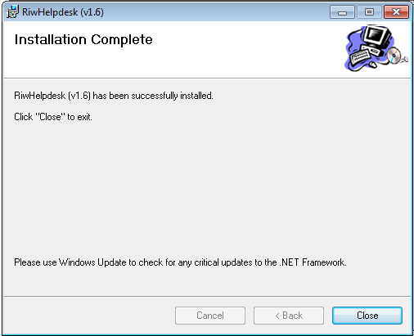

  - Click Close to Complete Set up of Helpdesk.

- Step 10 –(After Setup Give Permission to HD)

  - Open Folder where Your Hd Is Stored(..\inetpub\wwwroot)

  - Right Click on Your Hd Folder and Select Properties option.

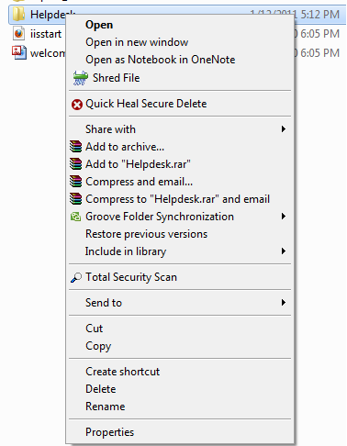

  - Select Security Tab and click Edit button to Give Permission.

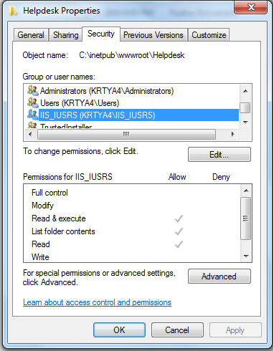

  - Select IIS Users For Group or User names list.

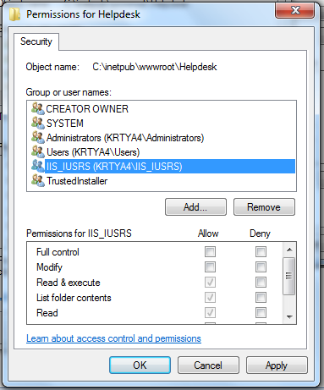

  - Tick Allow option of Full Control in Permissions for IIS_IUSRS List.

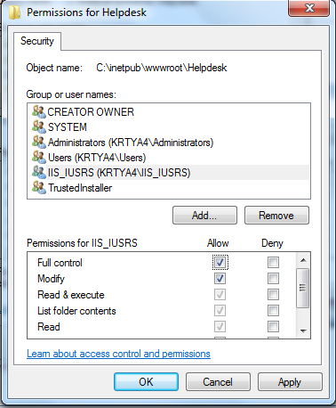

  - Click Apply and then ok to give Full Permission.

- Step 11 –(If 64 Bit Machine then Use This Step )

  - Open Run (window + R) and write inetmgr in it then press ok button.

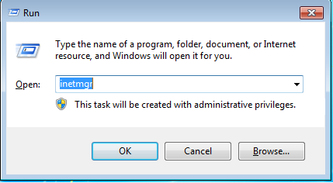

  - Select Application Pools Option.

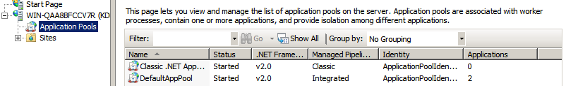

  - Right Click on DefaultAppPool Option and Select Advance Setting Option.

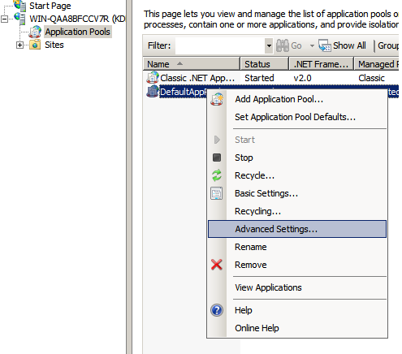

  - Set Enable – 32 Bit Application Property to True In General List.

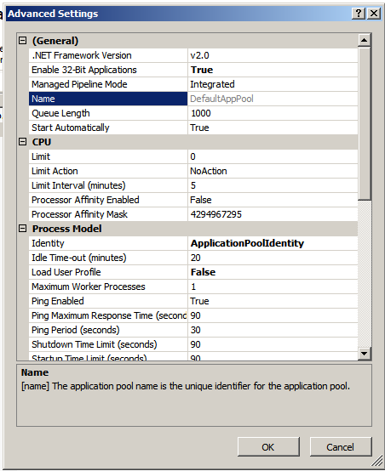

  - Click Ok to Save Setting.

